<Country Name> **Overview: Water, sanitation and hygiene**

Fig. 2: Thirty-five per cent of the population in <country> has access to safely managed sanitation services

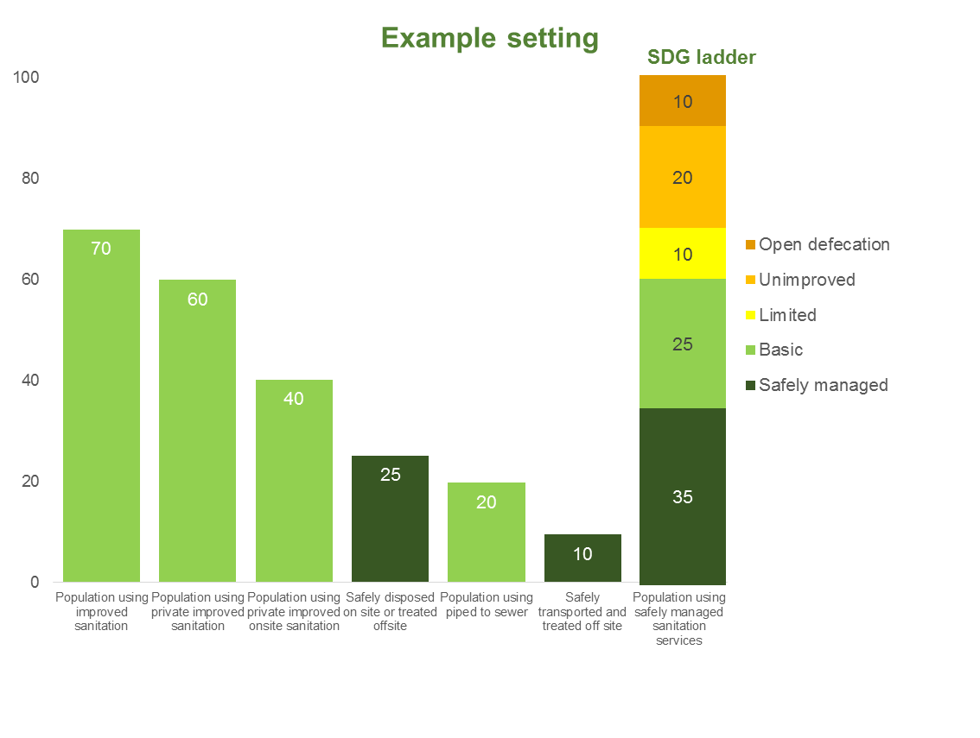

Fig. 1 Fifty per cent of the population in <country> has access to safely managed water supply.

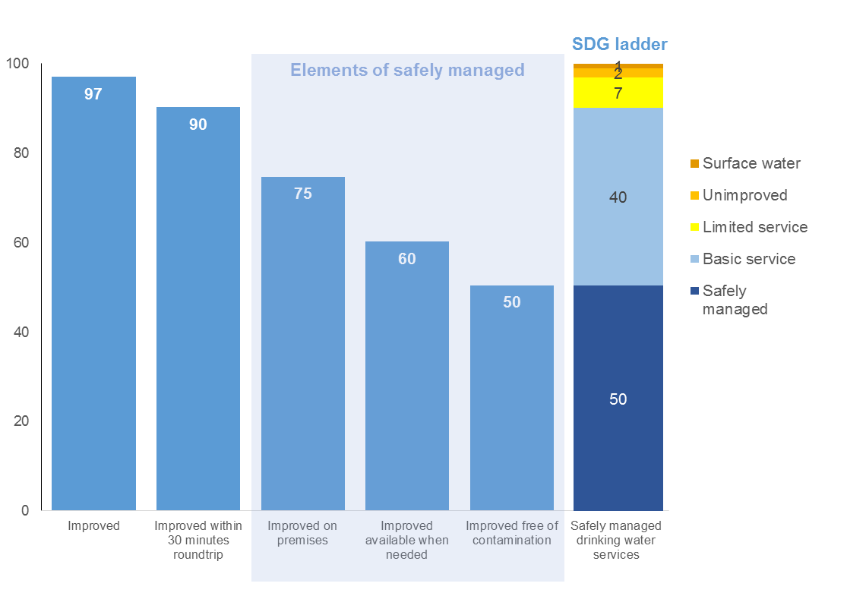

**Overview of the <country> vision and targets for the SDGs**

The water, sanitation and hygiene sector in <country> is guided by the [national] [sector] plan and strategy (2015- 2020). The strategy prioritizes the elimination of open defecation by <year> and achieving universal access to [safe] [basic] water services by <year> and [basic] sanitation by <year>.

In 2015, <country> achieved coverage of X% for water and X% for sanitation. This was [in] sufficient to achieve the [respective] MDG targets for <water> and/or sanitation. The more ambitious WASH targets and standards under the SDGs significantly raises the bar for what is required. <Country> will aim to achieve X% access to [safe][basic][safely managed] water supply and X% to sanitation by the year(s) X and Y respectively. The main challenges are lack of services or poor quality services for the poor in urban and rural areas, mainly in the area of sanitation and hygiene. Coverage and quality of services are significantly lower among vulnerable groups including the [categories of vulnerable groups e.g. disabled].

The critical bottlenecks to overcome include: weak sector governance and integrity, particularly the lack of separation of oversight from service provision; a heavy reliance on public financing and absorption challenges; human resource constraints; lack of a review mechanism to assess progress on a regular basis; limited multi-year funding agreements from partners which limits predictability of planning. If these are not resolved, progress will remain slow and the SDGs will be missed.

**Summary**

<Country> has a vision of achieving X% coverage of [safe] [basic] water supply by [year] and X% access to [safe] [basic] sanitation services by [year]. To achieve these targets, <country> will require $ X billion dollars annually, with significantly higher investments in the [short] [medium] term. Currently, the financing gap is estimated as $X billion. The ambition is highest for rural sanitation where coverage to basic level services are at X% and will require significant household participation to eliminate open defecation and progress to universal basic sanitation services. In addition, access to water and sanitation services is significantly lower in poorer communities and among vulnerable groups.

Five major actions to ensure an aggressive approach to progress include *(indicative)*:

1. Channel adequate public and private resources to urban sanitation, rural water and sanitation and hygiene
2. Scale-up strategies to eliminate open defecation in rural areas and improve access to basic sanitation levels
3. Identify and better target resources to improve coverage for vulnerable groups
4. Increase regulatory oversight in urban water supply and improve quality in order to achieve the new standards for safely managed services and enable utilities to be attractive for additional financing
5. Improve revenue collection and ring-fence financing for operating and maintenance costs

*(Additional examples include:*

* *Enhance the sector’s capacity to continuously monitor WASH service delivery*
* *Enhance the sector’s capacity for knowledge management and innovation for development of more cost- effective approaches and service delivery models)*

**2. Review of the sector – State of the Sector Building Blocks and Collaborative Behaviours**

<Country> is improving the foundations of a well-functioning sector. A national plan and sector strategy have helped to clarify the vision for the SDGs. There are some gaps which need to be addressed in a number of building blocks.

**[Policy and strategy]:** The strategy addresses the four sub-sectors and could be bolstered by decentralized plans to scale-up the reduction of open defecation in rural districts. Among policy issues, public support for sanitation hardware versus software must be clarified. The equity of resource allocation, particularly for targeting vulnerable groups, can be improved.

**[Institutional arrangements]:** Separation and clarification of roles is incomplete for all subsectors—especially rural and urban sanitation—including for governance, regulation, ownership and operations.

**[Sector financing]:** Public funding to the sector generally increased during the MDG period from X% in 1990 to Y% in 2015. Levels of disbursement and expenditure can still be improved to make the most of increased sector allocations.

**[Planning, Monitoring and review]:** A monitoring framework supported by an information system which integrates data on water and sanitation services in the education sector is in place. Next steps will be to include health facilities.

**[Capacity development]:** While finance for a national network of environmental health workers is available they have very limited operational funding and no capital funding to subsidize sanitation. Comparatively, the rural water and sanitation subsectors lack adequate management systems, finance and capacity to expand, and maintain services.

In terms of the SWA **Collaborative Behaviours**, government and development partners work together to improve the ways of working in the water, sanitation and hygiene sector. The government has led the process of developing the sector vision and strategy, which is focussed on achieving universal access by 2030. The majority of development partners have orientated their programs and funding to the achievement of this government-led strategy. More can be achieved if similar levels of alignment were achieved on the use of country systems. While the government is working to standardise and streamline procurement procedures, development partners will gradually and progressively aim to use the government defined procurement systems. In addition, funding from X development partners is on-budget. The government is working with partners to capture most of the funding on the national and sector plan as well as national budget.

While the monitoring and evaluation architecture is elaborate, greater use of the findings captured by information systems and reports is needed to drive performance improvements. In addition, the majority of development partners are yet to start using the monitoring framework jointly developed with the government.

*Suggested graphic: The SWA Collaborative Behaviours Country Profiles will have information which can be presented in a graphic*

Fig 1 Application to the SWA Collaborative Behaviours by government and partners, <country>



**Priority actions to be taken to ensure the readiness of the sector for the SDGs**

* Develop decentralized plans to scale-up the reduction of open defecation in five rural districts
* Increase the share of public resources allocated to rural water and sanitation
* Amend the policy to fully define governance, financing and oversight roles of rural water and sanitation and clearly separate the service provision and oversight functions for urban and water and sanitation services
* The government and development partners will gradually increase the amount of development financing on national budget, starting by putting sector financing on the sector plan
* Government will make procurement procedures more transparent and development partners will progressively increase the use of these systems

Fig 5 <Country> will require <$881m> to build and maintain universal basic coverage

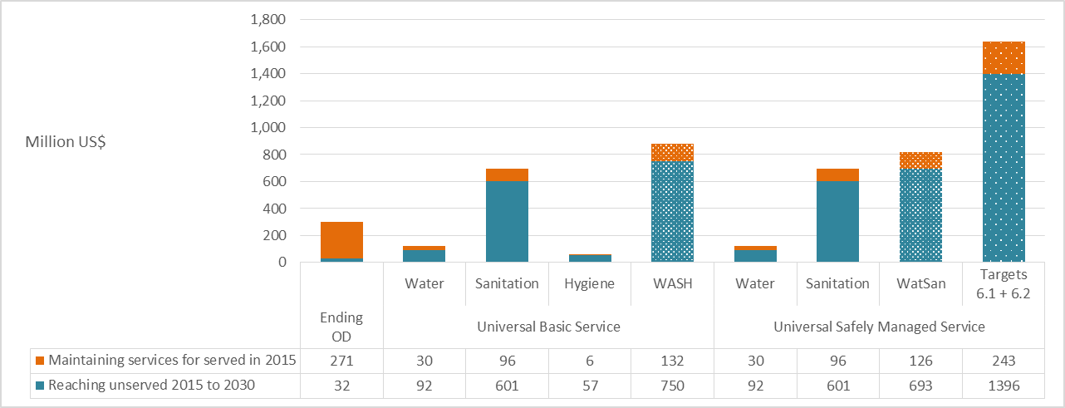

Fig 6 Financing gap: current public funding compared with annual costs intended to be met from public funds, in US$ million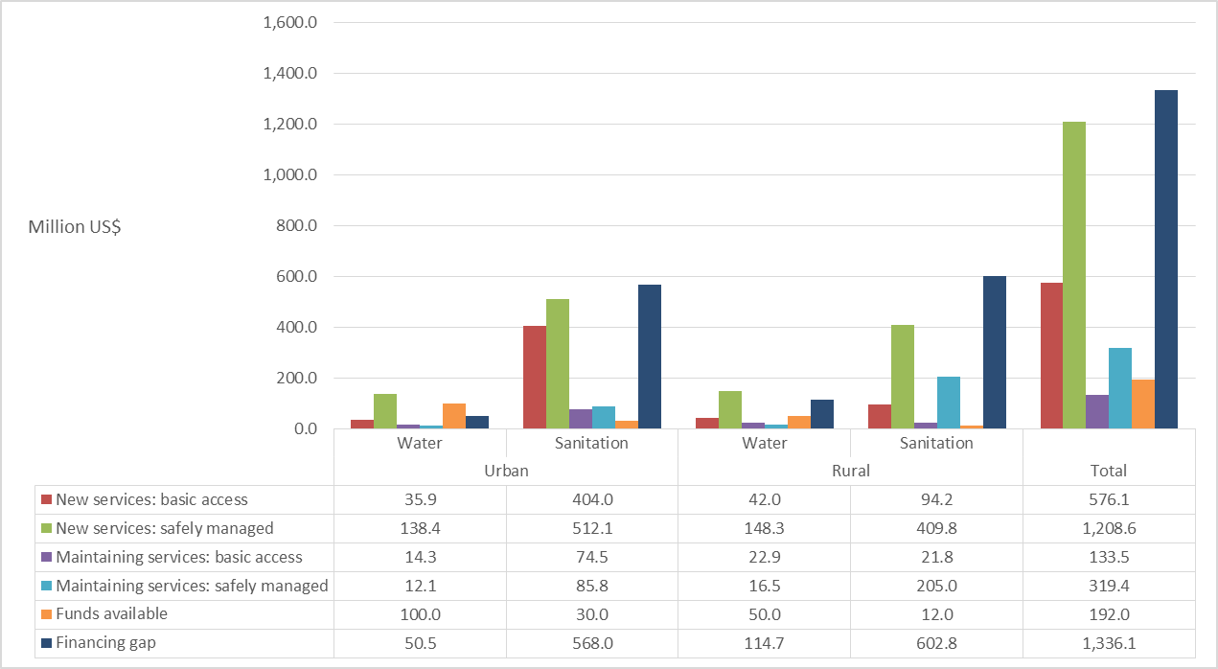

**3. Sector investment needs, the financing gaps and areas for improving efficiency**

**Investment needs and funding gap**

<Country> will require $ X million dollars per year to achieve the water, sanitation and hygiene SDG targets. The largest share of the investments will be targeted at [capital/recurrent] expenditures in the medium-term and mostly dominated by investment needs in [rural] [urban] [water] [sanitation]. These costs are driven mostly by [population growth due to migration in urban areas], [rehabilitation to maintain services], [new construction to expand services]. Currently, the financing gap is estimated as $X billion. The deficit is mostly in rural sanitation and hygiene where current funding projections cover X% of the costs and households are expected to rapidly increase their contributions.

**Strategies to close the financing gap**

Projections of available finances indicate higher allocations and more predictable funding streams from taxes. However, taxes alone will be insufficient to guarantee the aggressive nature of progress which is required to achieve the SDGs. A combination of domestic revenues, more efficient allocations and use of available financing as well as accessing commercial revenue is needed. The most viable options for mobilizing additional resources include accessing domestic private markets and commercial resources. In addition, inefficiencies must be curtailed particularly those emanating from poor revenue collection, high levels of non-revenue water, poor functionality and high operating costs. These make the water and sanitation service providers an unattractive investment for commercial finance which is needed to expand coverage and sustain services.

The current contribution of tariffs to operations and maintenance can be further improved if quality of services is high. To achieve the SDGs and particularly to mobilize additional funding, an aggressive resource mobilization strategy, which combines higher household and public contributions as well as access to commercial financing is needed. In addition, cost saving measures will be needed particularly by using alternative energy sources for utilities.

This country brief was prepared by the <Ministry of Water Supply and Sanitation> with the participation of partners including <development banks, bilateral agencies, civil society, private sector and research and learning agencies>.

**4 Planned actions to catalyze progress towards the SDGs –where possible be specific about the lead agency for each action**

**Steps the government and partners are prepared to take to make the sector fit for purpose**

1. **[Policy and strategy]:** Ministries responsible for water, sanitation and hygiene will support districts/counties to develop plans which include the SDGs and the elimination of open defecation by 2025
2. The Ministry of water and sanitation will work with other ministries and agencies to amend the national policy and ensure that oversight functions are separated from service delivery roles by 2020
3. **[Capacity development]:** gradually increase the number of personnel needed to oversee regulation of service provision to reach the optimum staffing by 2020

*Relevant (SMART) actions to ensure the Collaborative Behaviours are applied*

1. By 2020, the ministry of water and sanitation, working with other sector actors, will develop and put in place a review mechanism to assess progress on a regular basis and ensure that results are acted upon
2. Development partners will progressively begin to use country procurement procedures with the view to fully align with the government by 2025

**Plans and strategies to reduce the financing gap**

1. Plans to use existing resources more effectively:
2. Utilities will gradually improve cost saving measures, particularly in energy use
3. Ministries and spending agencies will improve the resource allocation strategies to better target X% of vulnerable groups by X [year]
4. To assure transparent management, utilities will provide publicly audited annual reports
5. Plans to access more financing:
6. To achieve urban sanitation, the government and service providers will work towards improving household contributions from 5% to 10% of the needed operating costs by 2030
7. Working with utilities, the government will revise tariffs by [x]% of capex by 2020, gradually increasing by [x]% per year by 2030

Country flag or logo